EC2

EC2 is one of the most widely used and one of the most popular services that AWS provides

EC2 ->Elastic Cloud Compute

The word compute means you are requesting AWS to provide you a compute instance which is a combination of CPU, RAM, disk, and Virtual Server.

What is virtualization?

What is a hypervisor?

AWS has multiple physical servers across the world…

What is elastic in AWS??

If AWS provides a service that can be scaled up(increase the resources) or scaled down(decrease the resources or you can use anywhere). That service is elastic in nature..

EC2 means Elastic cloud computing where you are requesting AWS the public cloud provider to give u a virtual server, virtual machine which is elastic in nature and this term is generally called as compute. That’s why u called it as Elastic cloud compute.

Why EC2 instance or why Should I use an EC2 instance?what is an advantage if I use an EC2 instance?

What are different types of ec2?

LAB

First login, go to ec2

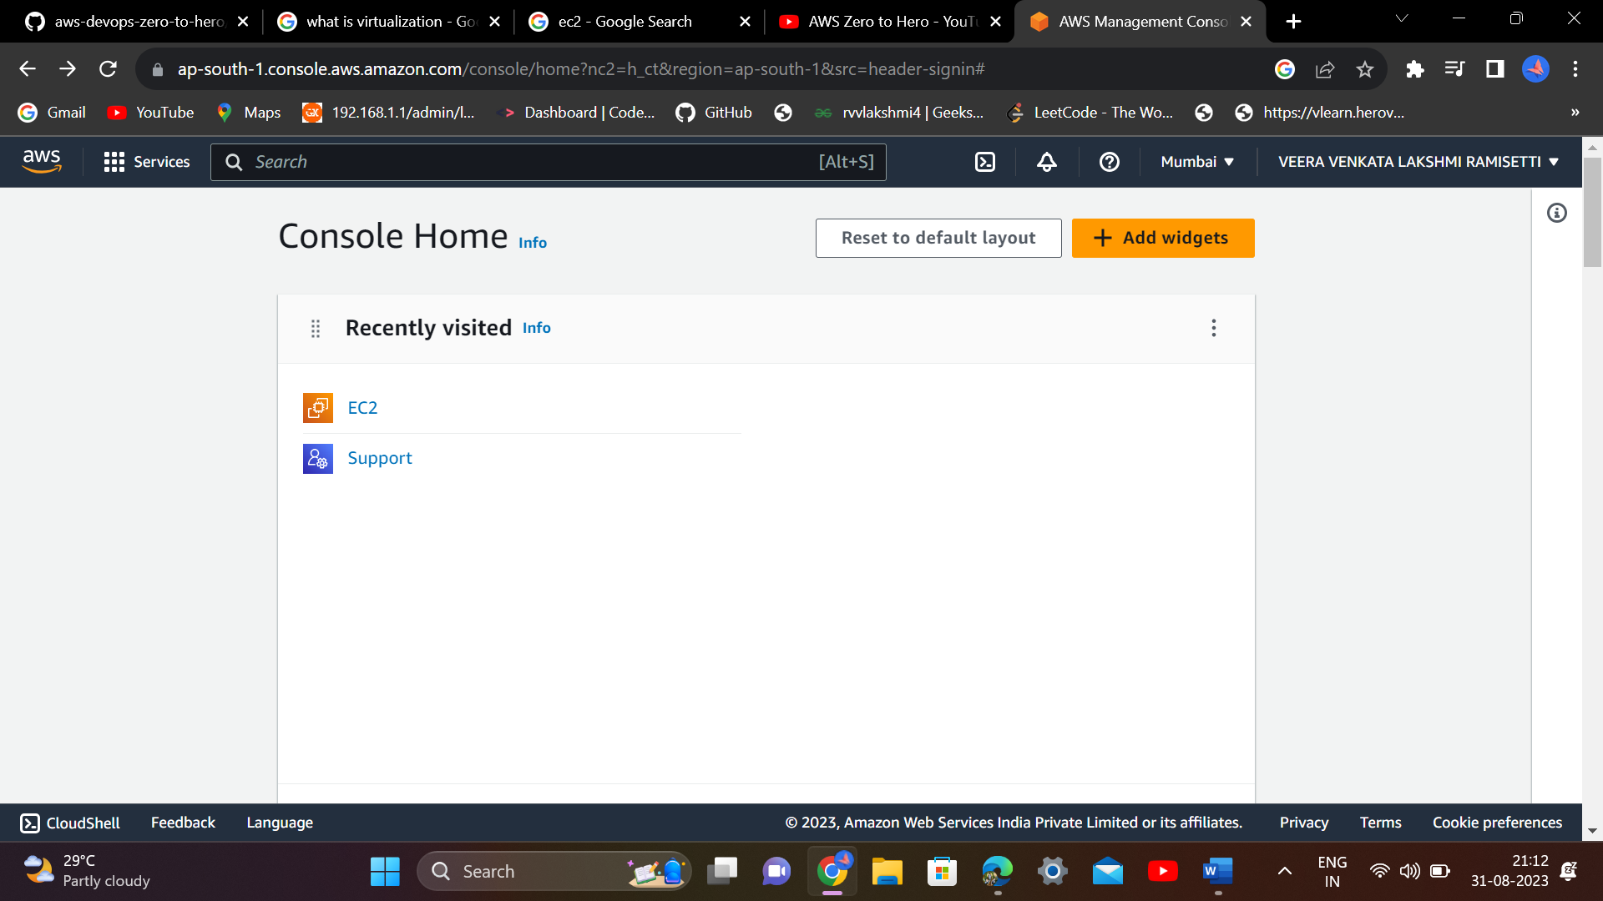

Click on “launch instance”

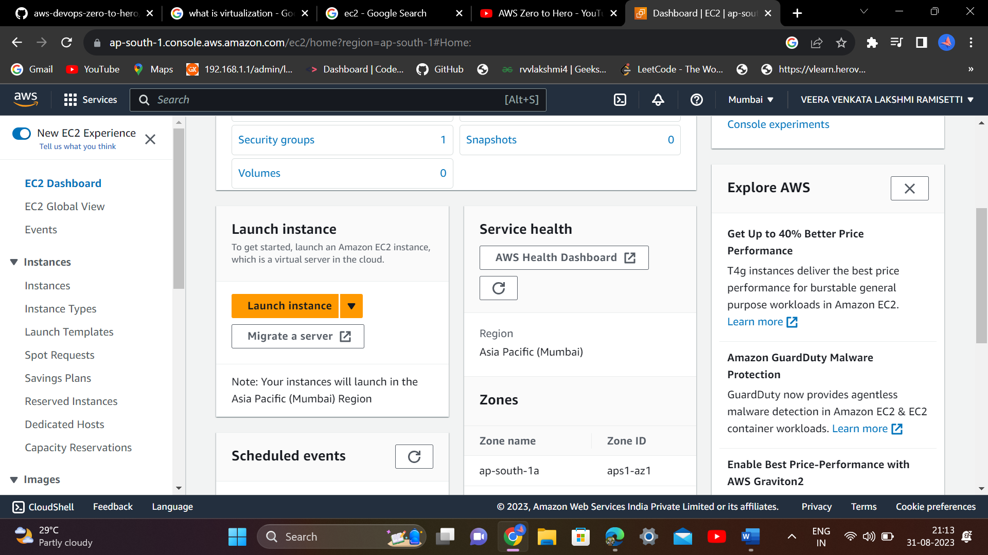

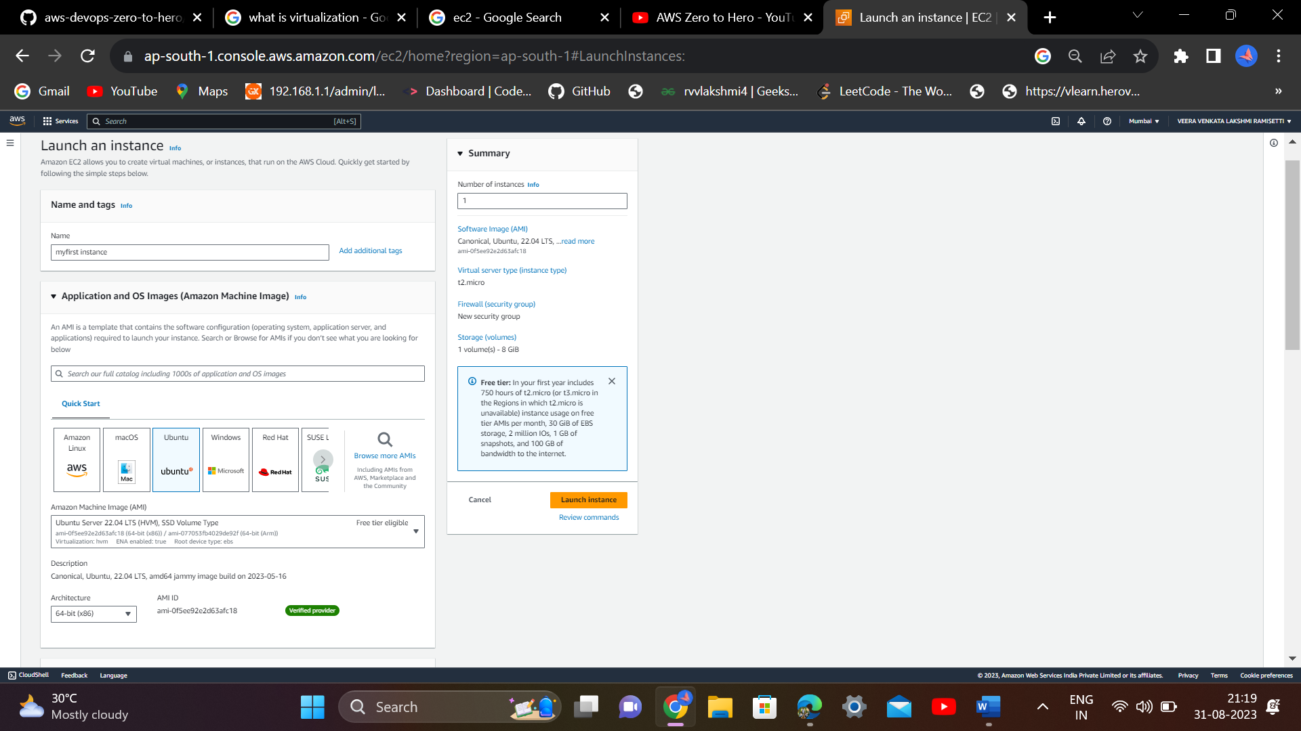

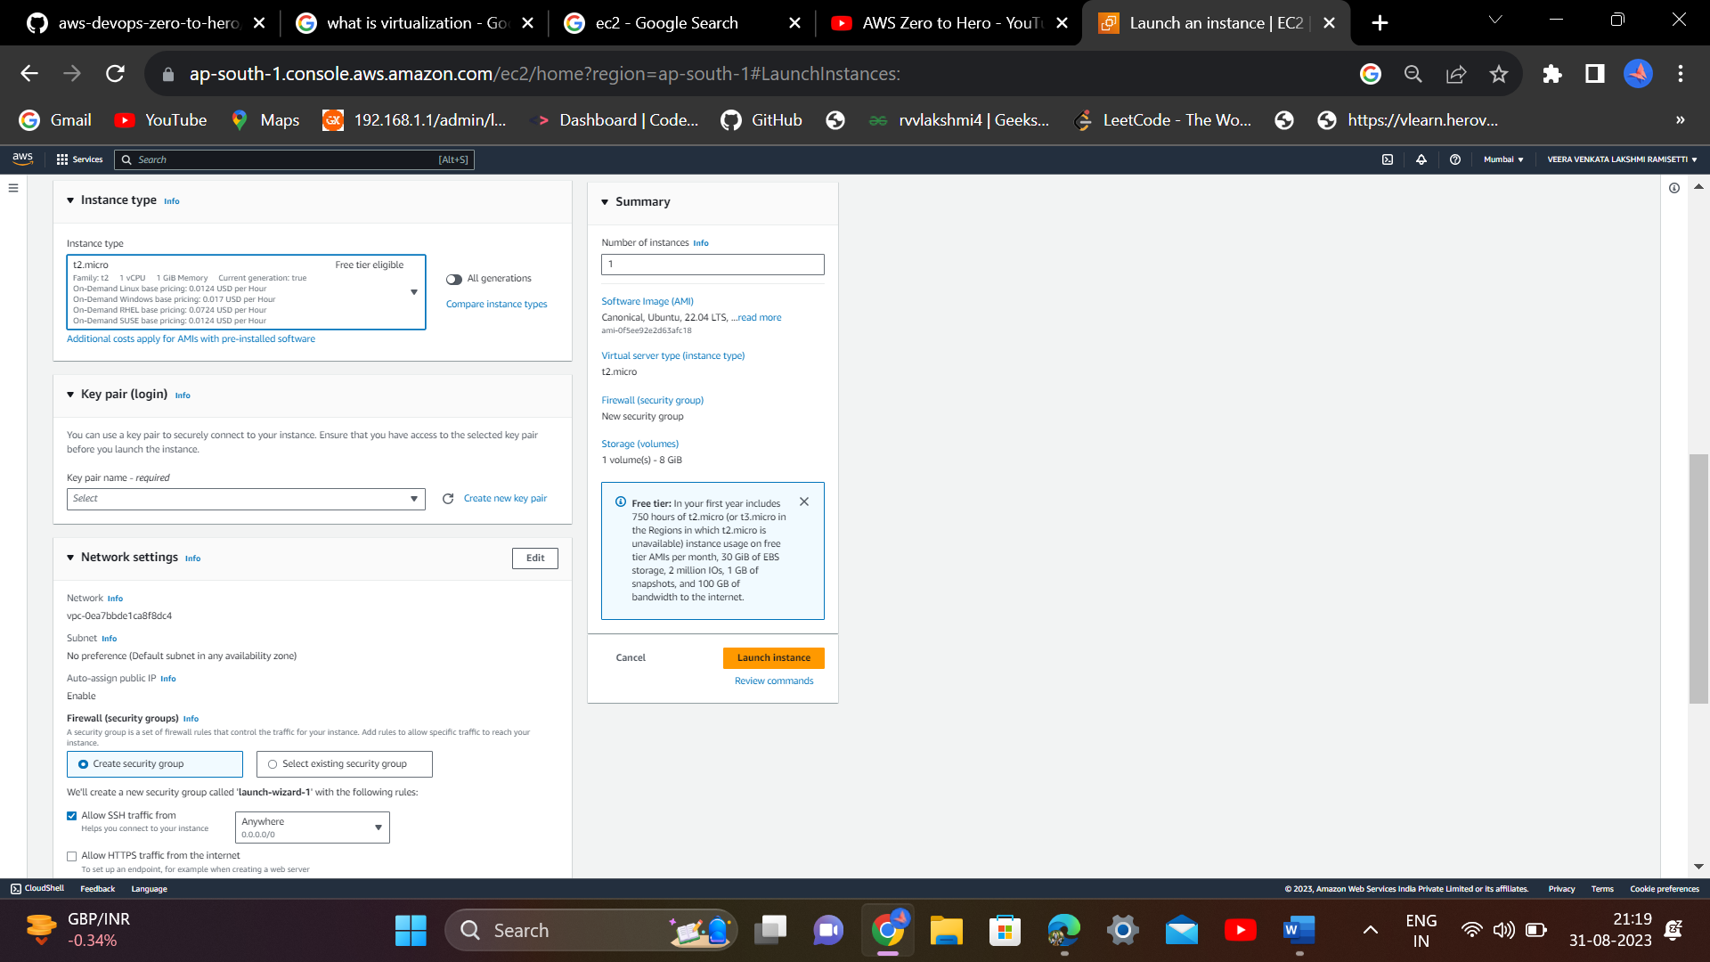

What is key value pair?

Key value pair means combination of public and private key which u used to login to that specific instance.

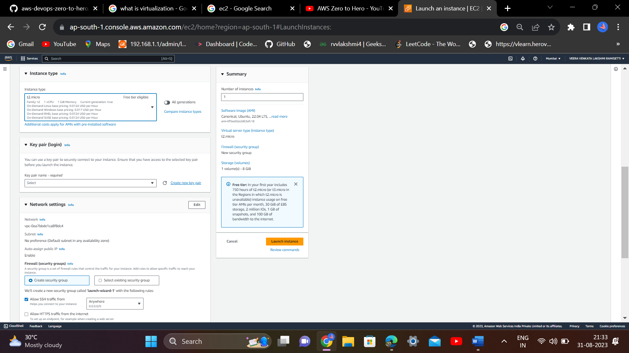

Select create new key pair

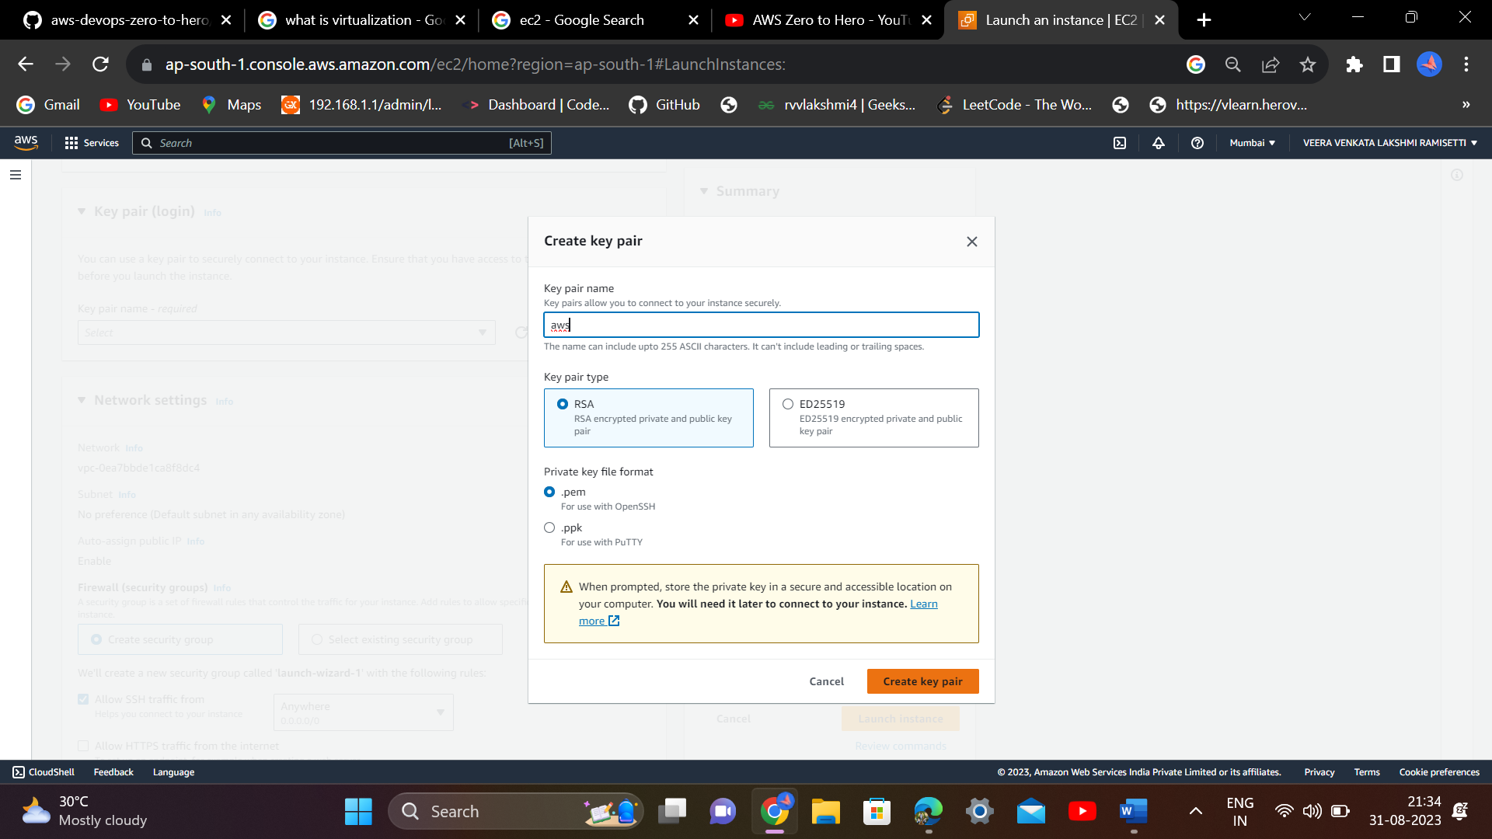

Give any name

And don’t change any data…select create key pair

A pem file will be download.

And gb is 8…click on launch instance

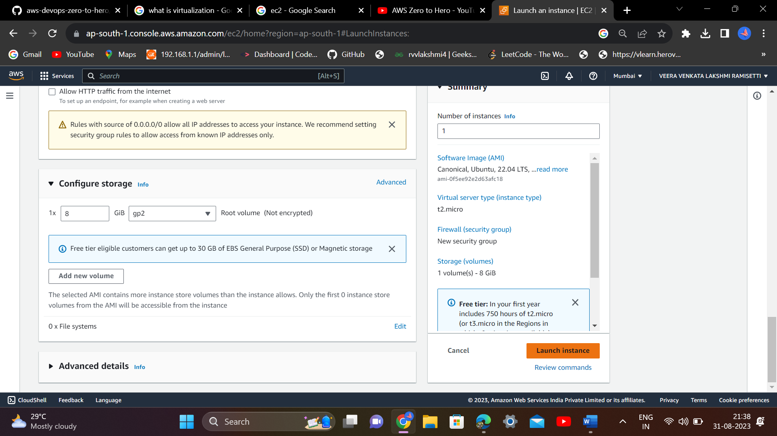

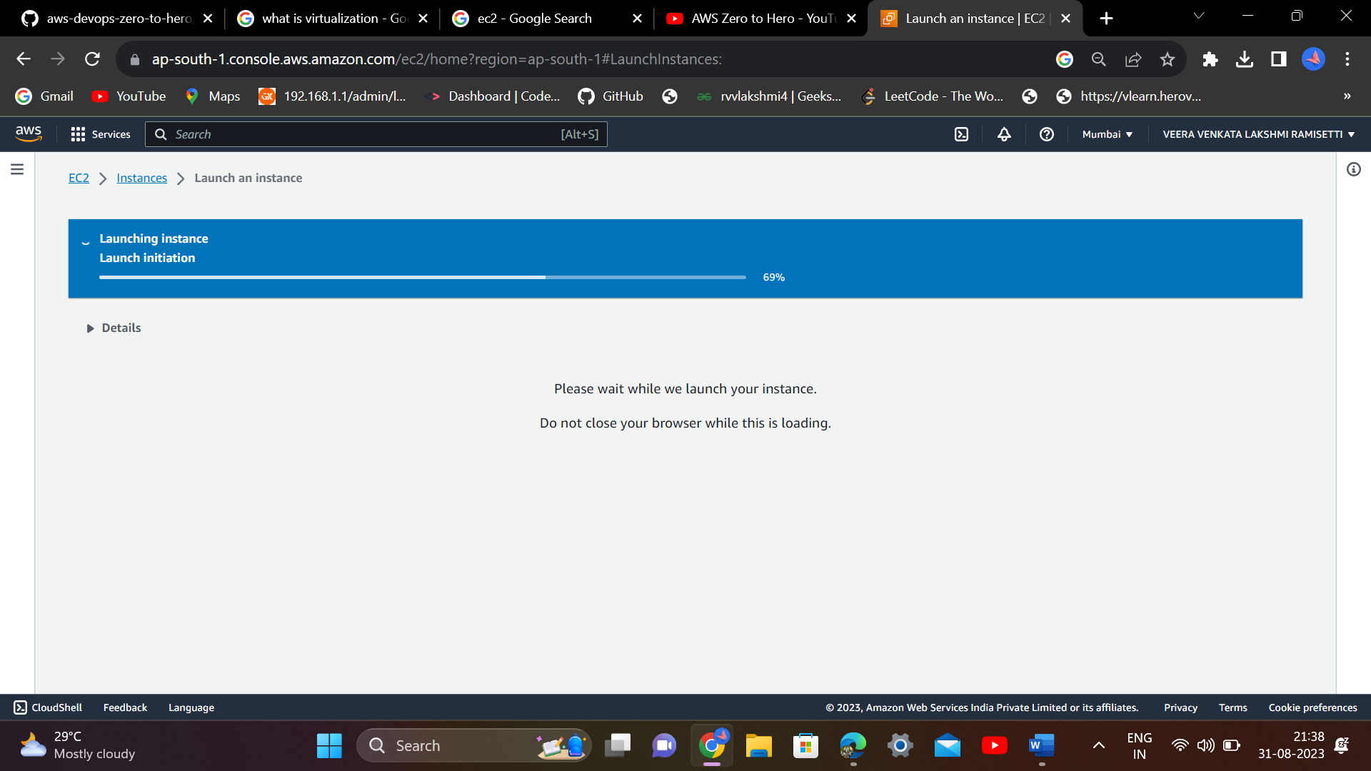

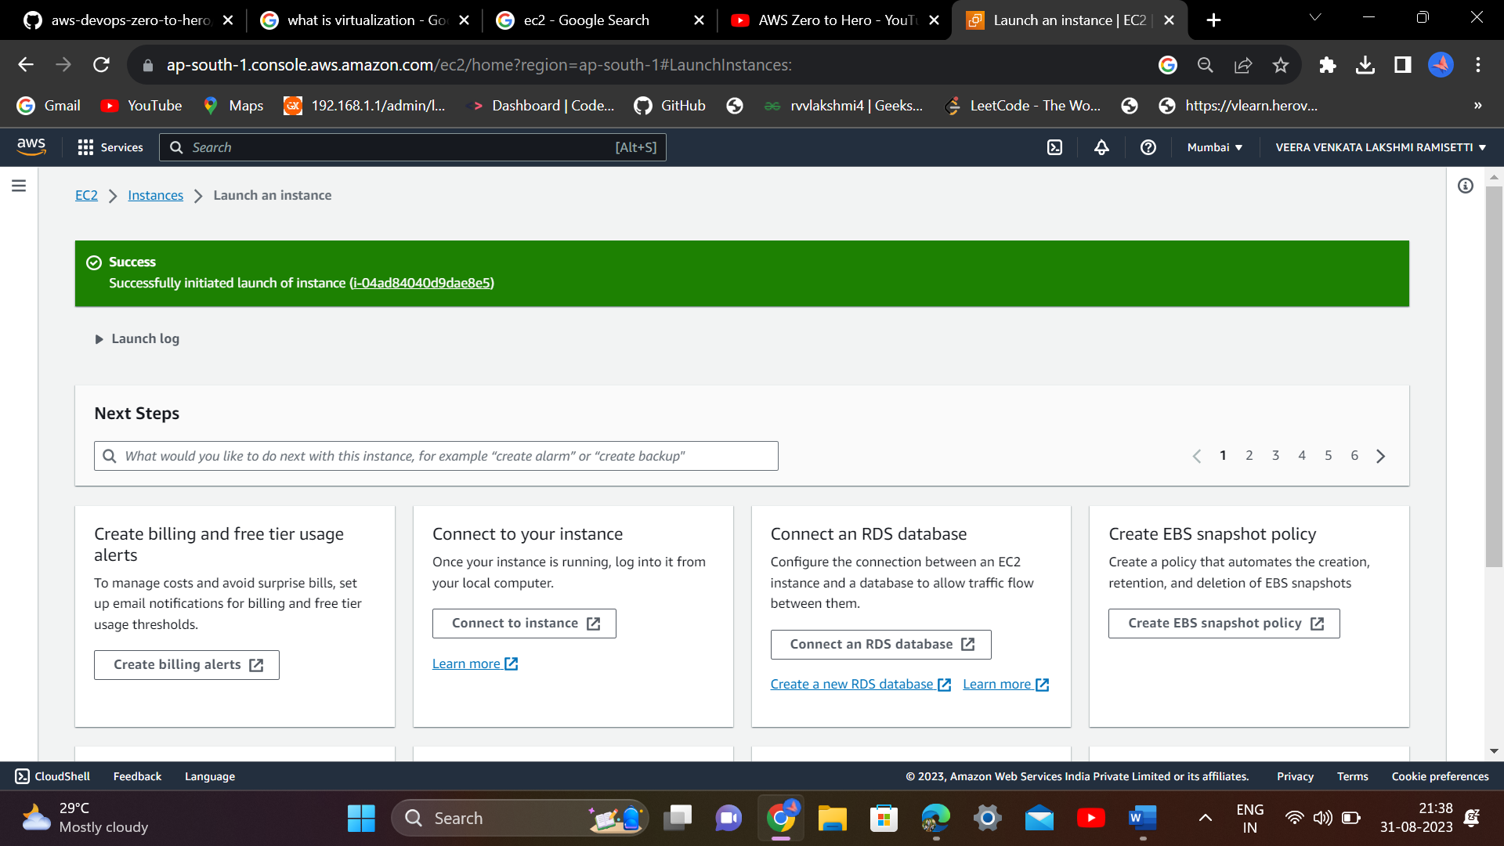

To login to this machines, get mobaxstream or putty

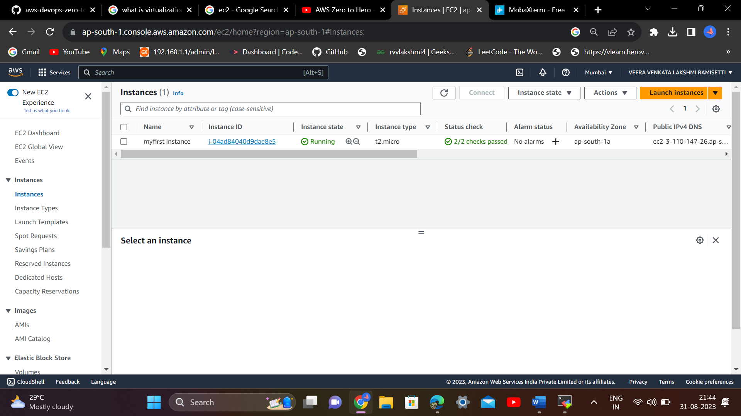

U have to wait for the instance to be in running state

To get the complete details of the instance,click on instance id

Using public ip address, we can access the instance from outside world

Using private ip address, this is very specific to aws network

For logging into AWS, public ip address is used

Use portable version to download

After downloading, we have to extract it

Copy public ip address

3.110.147.26

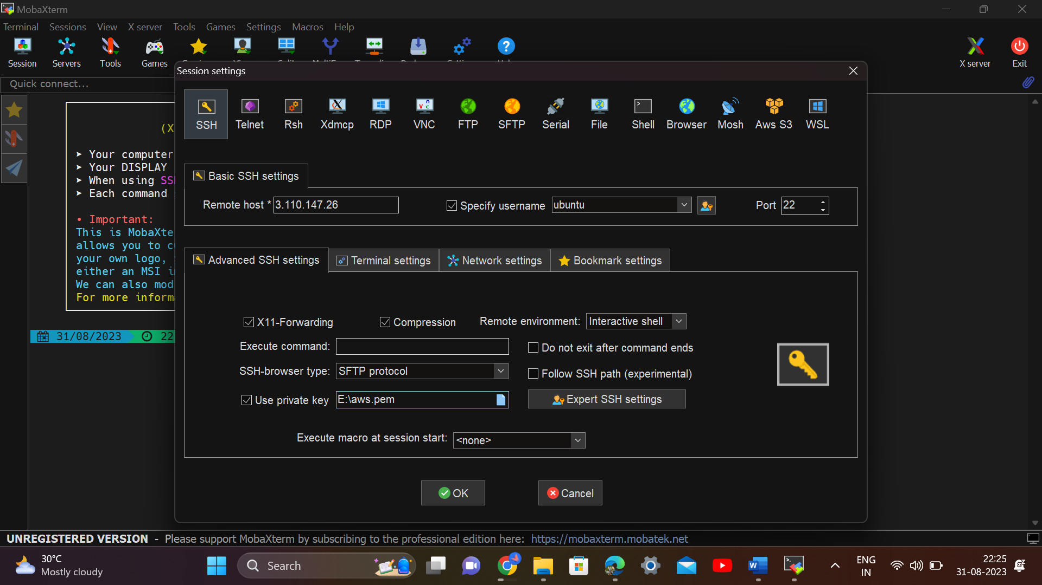

Use public ip as remote host and select specify username (username as ubuntu ) select advanced SSH settings …and select use private key option and use pem file then click on ok,…

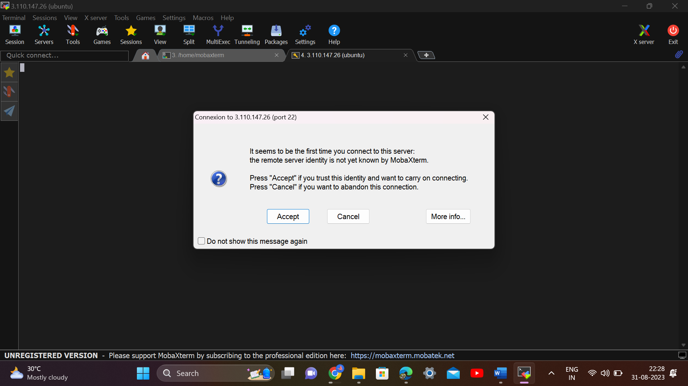

Click on Accept

